HP UNIFIED FUNCTIONAL TESTING

QTP stands for **Quick Test Professional**, given by Hewlett Packard (HP). QTP is a software [application](http://www.softwaretestingclass.com/introduction-to-hp-unified-functional-testing-uft/) used for Automation Testing process to test the software applications, more useful for“Functional” and “Regression” testing.

QTP’s user interface is called as an Integrated Development environment (IDE) for the test itself, IDE comes with various features which motivate testers to develop a complete script which will effectively validate the determination of the test.

QTP runs only in a windows environment and uses “VB Script” scripting language is one that gets interpreted at run time.

It supported technologies totally depends on the version of QTP is accessible for Web, Java (Core and Advanced), .Net, WPF, SAP, Oracle, Siebel, PeopleSoft, Delphi, Power Builder, Stingray 1, Terminal Emulator, Flex, Web Services, Windows Mobile, VisualAge Smalltalk, [Silverlight](http://www.softwaretestingclass.com/introduction-to-hp-unified-functional-testing-uft/) and mainframe terminal emulators.

The latest version of QTP is 11.5; this new version of QTP is named as HP Unified Functional Testing (UFT). Basically, the **UFT is a mixture of HP QTP (**GUI testing tool**) and HP Service Test (**API testing tool**). Mixture of QTP and ST**will be available on a single graphic user interface. So from now onward, user does not have to[download](http://www.softwaretestingclass.com/introduction-to-hp-unified-functional-testing-uft/) two different tools while working.

[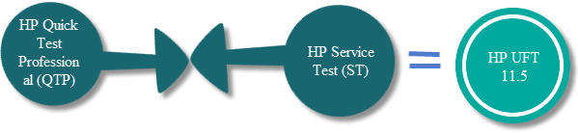](http://www.softwaretestingclass.com/wp-content/uploads/2014/04/uft-latest-version-of-qtp.png)

Latest version of QTP supports Web, Java .Net, SAP, Oracle, Siebel, PeopleSoft, Web Services, and many other major languages and platforms, but some older versions do not support all above mentioned languages and platforms.

HP UFT 11.5 will also facilitate open source Continuous Integration(CI) systems like Jenkins and Hudson. While, understanding the need of phone (smart-phones + tablets) among users, HP is more giving attention on this;HP’s UFT 11.5 will deliver an enhanced [support](http://www.softwaretestingclass.com/introduction-to-hp-unified-functional-testing-uft/) for mobile testing. With this HP UFT Mobile support, HP says that user will be able to generate mobile platform agnostic scripts.Agnostic scripts which has been created iOS, can also work on Android. It will also support emulators and real devices. The real devices can be taken from the public cloud of collective real devices and/or private cloud of devoted real devices.

Automated Testing Process and Progress Steps:

Any automated tool execution process has to go through the following steps given below in the figure. Here each step performs particular activity for better result.

[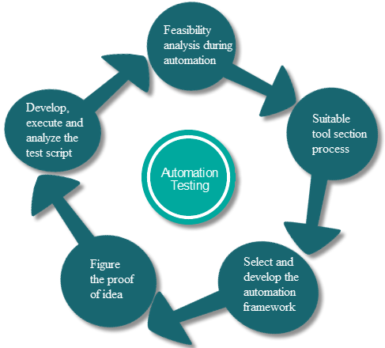](http://www.softwaretestingclass.com/wp-content/uploads/2014/04/qtp-uft-automated-testing-process-and-progress-steps.png)

**Feasibility analysis during automation:**Before doing automation testing on software, it is necessary to check that the software can be automated or not, because user cannot automate all software due to some reason.

**Suitable tool section process:**Select the automation tool depends on the software requirement, function, and usage.

**Select and develop the automation framework:** After selecting automation tool,the next process will be to select an appropriate framework for automation. There are different kinds of frameworks and each framework has its own quality. Also, develop the framework that is very important process of any successful test automation project.

**Figure the proof of Concept:**Proof of Concept(POC) is established with an end to end setup to estimate if the tool can support the automation of the application. Although, it is achieved with an end to end setup which will confirm that the main functionality can be automated.

**Develop, execute and analyse the test script:**After script get developed,the scripts should go for execution,result analysis, and defect logging. Usually, test scripts are version controlled.

**HP Unified**[**Functional Testing**](http://www.softwaretestingclass.com/overview-of-hp-unified-functional-testing-12-0-training-tutorial-3/)**(UFT)** is a combined platform of GUI testing API testing to test the front-end (User interface) and back-end of the software [application](http://www.softwaretestingclass.com/overview-of-hp-unified-functional-testing-12-0-training-tutorial-3/). GUI testing method can be used to test front-end of the software application and API testing method can be used to test back-end of the application.

Using UFT, user can test either whole application from start – to – end or can test a particular function and object of an application through the creation of individual actions or components. Later on, user can combine the individual actions or components into a test.

HP UFT also facilitates ALM, a centralized quality control solution. User can save tests, components, function libraries and application areas with the ALM project and create them obtainable to several users and testing projects.

# UFT ALM feature:

Now, ALM site administrator can set a site parameter that initiates UFT to temporarily upload run results from a run session to ALM. Because of this administrative privilege, the results always be uploaded, or user can use site parameter arguments to identify the condition of each of the uploaded result. After parameter is set, all sites projects can use the parameter when running UFT tests.

# UFT Interface:

UFT interface provides various elements to design, edit, debug, and run testing application. These elements are,

**Start Page:**Welcome page of UFT, provides options to create new testing document and to open the existing one.To reach on this page,

[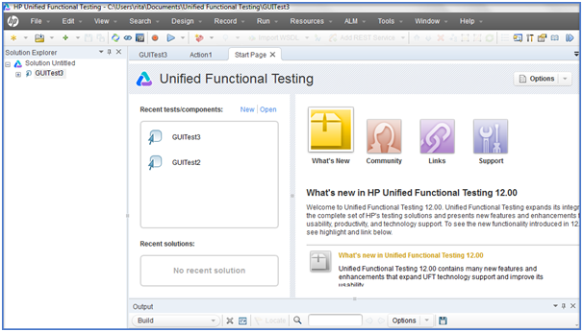](http://www.softwaretestingclass.com/wp-content/uploads/2014/04/uft-interface-page.png)

First: Go to Start menu, click on All Programs > HP Software > HP Unified Functional Testing > HP Unified Functional Testing.

Second: After installation of UFT, the shortcut has been placed on the desktop double-click that to get the start page.

Third: In the opened UFT window, if you are unable to see Start Page, open it by selecting View > Start Page.

# Document Pane:

It is a main area which includes three platforms to design and edit testing documents. These three platforms are,

## 1) Canvas View:

The canvas delivers a graphical picture of the test flow.

[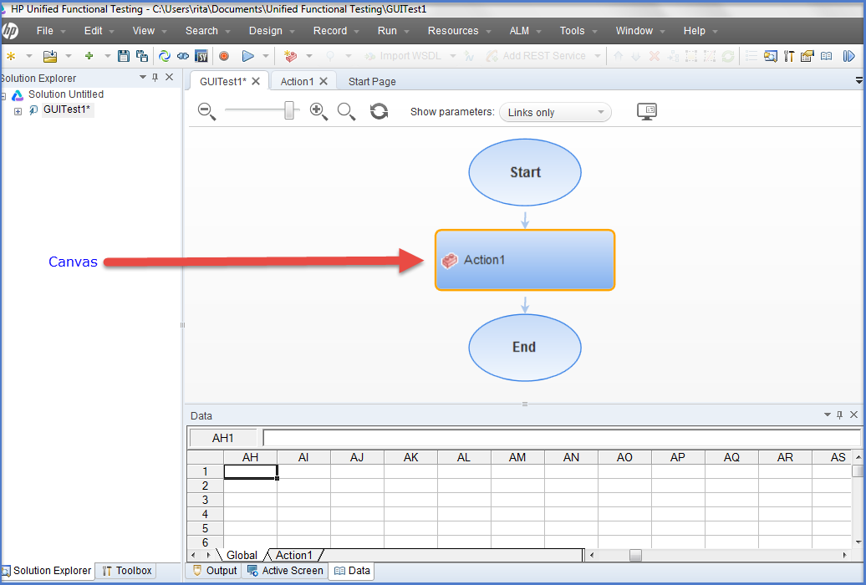](http://www.softwaretestingclass.com/wp-content/uploads/2014/04/uft-canvas-view.png)

In case of GUI testing,the canvas displays the flow of the action calls created during testing process, involves calls to copies of actions or calls to present actions.

In case of GUI testing,the canvas displays a flow of steps created within a test with parameter links stay between steps. User can use Toolbox pane to add steps to the canvas.

## 2) Editor View:

The Editor displays each step of the test in code form and facilitates user to add steps to a document or user code file using VBScript code.

[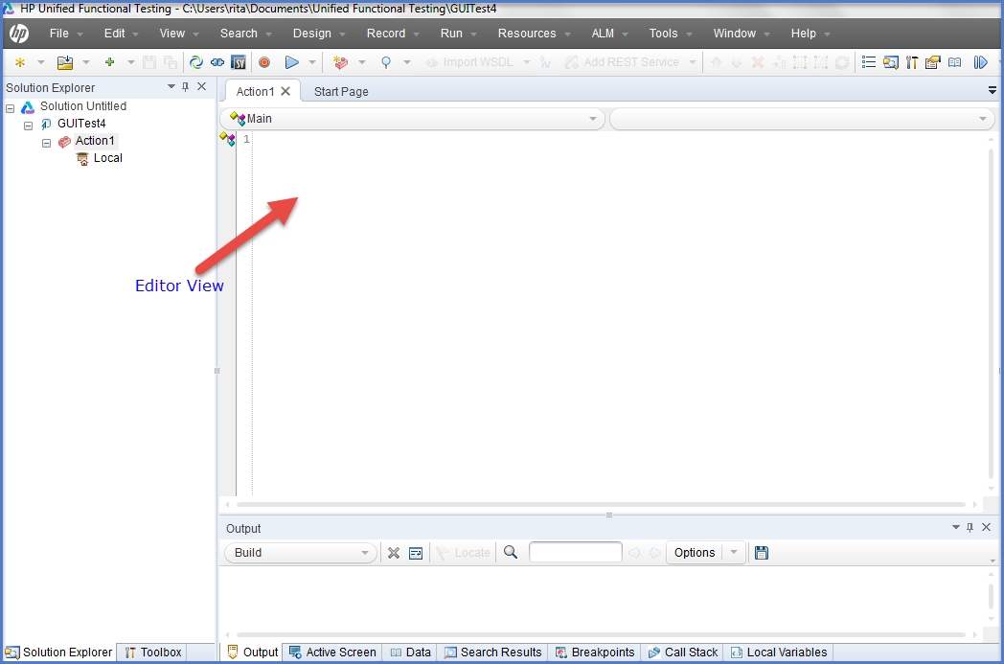](http://www.softwaretestingclass.com/wp-content/uploads/2014/04/uft-editor-view.png)

In case of GUI testing,each operation performed on the application during test displays in the form of VBScript coding language. For each object and method in an Editor statement, a consistent row exists in the Keyword View.

In case of API testing,the Editor facilitates user to write customized user code for API tests run through test steps or to write custom code which defines the properties and behavior of different test steps.

## 3) Keyword View:

This view facilitates user to generate and view the steps involved in GUI testing or component in a keyword-driven, modular, table format. The Keyword View is included of a table-like view, where each step will display in a separate row of the table, and each column signifies dissimilar parts of the steps. User can modify the columns shown to suit their needs.

[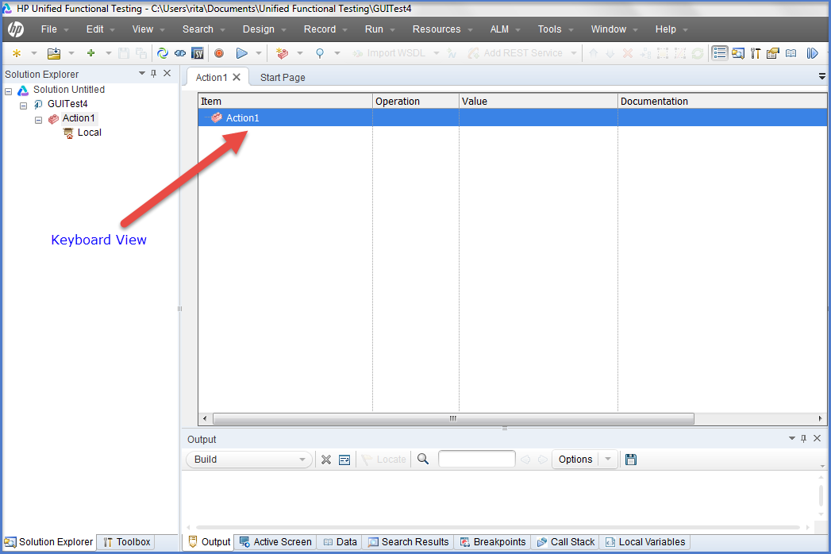](http://www.softwaretestingclass.com/wp-content/uploads/2014/04/uft-keyword-view.png)

User can generate and change GUI tests or components by choosing items and operations in the Keyword View and entering information as required. As soon as user completes the document, immediately all steps get documented, enables user to view an explanation of the test steps in understandable English format.

Each process completed on the [application](http://www.softwaretestingclass.com/overview-of-hp-unified-functional-testing-12-0-training-tutorial-3/) during a recording session is recorded as a row in the Keyword View.

Values of each row in the Keyboard view, displays in the Editor view as a script. If users focus on exact step in the Keyword View and switch to the Editor, the cursor is located in that corresponding line of the test.

# UFT Panes:

Delivers information and functionality about the current test, business component, function library or application area. It includes,

* UFT Window Layout
* Active Screen Pane
* Bookmarks Pane
* The Canvas
* Data Pane
* Debug Panes
* Document Pane
* Errors Pane
* Output Pane
* Properties Pane
* Run Step Results Pane
* Search Results Pane
* Solution Explorer Pane
* Tasks Pane
* Toolbox Pane

# Active Screen Pane:

The Active Screen offers a snapshot of that particular [application](http://www.softwaretestingclass.com/overview-of-uft-panes-uftqtp-training-tutorial-5/)under test on which some action has been performed during the recording session. Also, the Active Screen page contains detailed property information about each object as like the original page displays.

To vision the Active Screen, select [View](http://www.softwaretestingclass.com/overview-of-uft-panes-uftqtp-training-tutorial-5/) > Active Screen.

[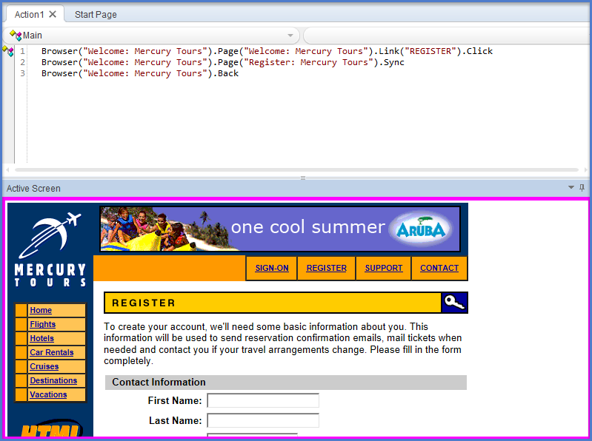](http://www.softwaretestingclass.com/wp-content/uploads/2014/04/UFT-QTP-Active-Screen-Pane.png)

# Bookmarks Pane:

The Bookmarks pane shows all bookmarks kept during test, it can be components, function libraries, user code files, etc. The pane allows users to generate bookmarks, see the detail about injected bookmarks, and traverse to the document comprising the bookmark.

To vision the Bookmarks pane, select View > Bookmarks.

[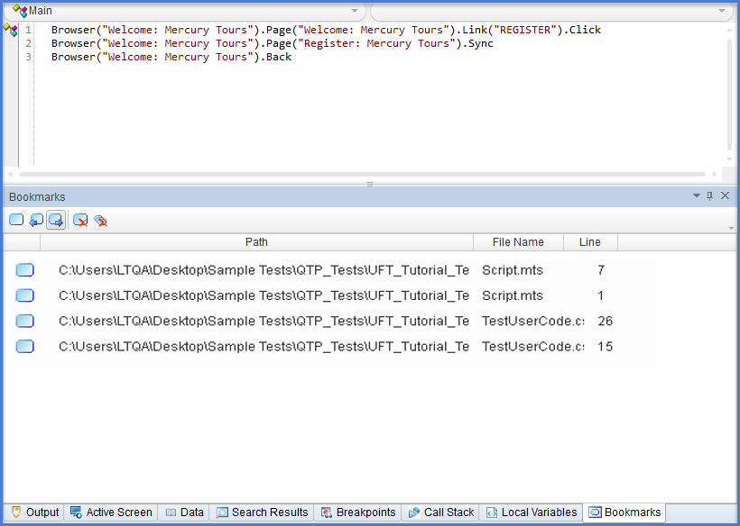](http://www.softwaretestingclass.com/wp-content/uploads/2014/04/UFT-QTP-Bookmark-Pane.png)

# Data Pane:

The Data pane shows the data related to the test or component, or business process testing flow. It displays the data in spreadsheet table with numbers of columns and rows which will be helpful in parameterizing that data.

To display the Data pane, select View > Data.

[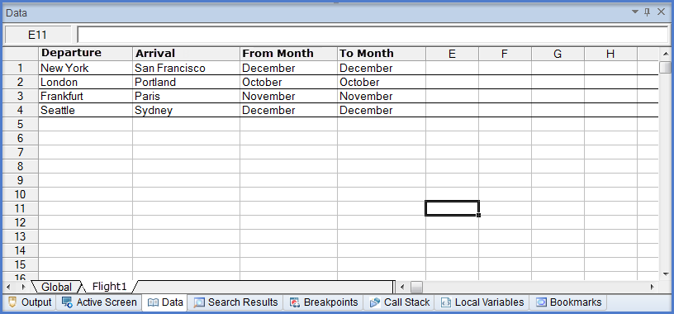](http://www.softwaretestingclass.com/wp-content/uploads/2014/04/UFT-QTP-Data-Pane.png)

# Errors Pane:

The Errors pane displays errors comes because of test like; missing resources and coding syntax errors. Detected errors automatically display in the Errors pane, if it is not opened too. To know the source of the error, just double-click on the error to see the particular error belongs to which data, component, or path.

Missing resources are the resources that are available in the test or component but during run time of the application or function, application does not get the exact sources. Information errors offer a list of coding syntax errors in the test or function library scripts.

To view the Errors pane, select View > Errors.

[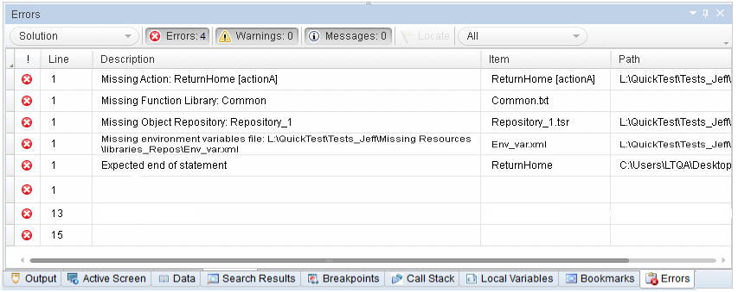](http://www.softwaretestingclass.com/wp-content/uploads/2014/04/UFT-QTP-Error-Pane.png)

# Debug Pane:

The Debug pane provides various options that are given below,call users to debug their document or code file,

Breakpoints: Shows the breakpoints detail available into tests, function libraries, or user code files and permits user to enable or disable the breakpoints.

Call Stack: Shows the detail information about the function and method calls presently running in a test, function library, or user code file.

Loaded Modules: Available for API testing only,shows detail information about the .dll files related with the present run session.  
Threads: Available for API testing only,shows detail information about all the threads running in the existing context of the test.

Local Variables: Shows the present value and type of all variables that were documented up-to the last step done throughout the run session that user is debugging. User can also change the value of the variable, manually.

Console: Facilitates user to run lines of script to set or change the present value of a variable, code object, property, method, or function call in the test or function library.

Watch: Shows the present value and type of any variable or expression that user added to the Watch pane.

To see the Debug pane options, go to View > Debug and select the required debug pane.

[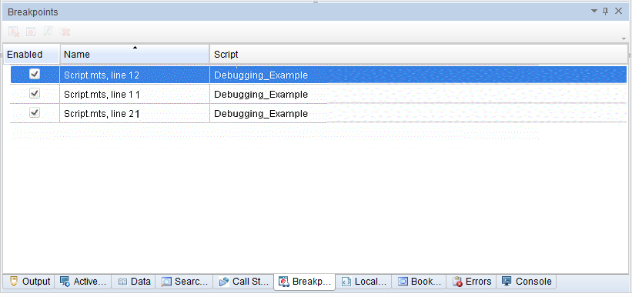](http://www.softwaretestingclass.com/wp-content/uploads/2014/04/UFT-QTP-Debug-Pane.png)

# Window Layout:

Window layout facilitates user to change the layout of the UFT window like;user can move and resize panes, select to show or auto-hide panes, create tabbed panes, and select which toolbar to display. User can also re-establish the default layout. User can customize the UFT window as per the requirement of each type of UFT session like; view/edit, record, and run sessions.For example; full screen the UFT to create or edit the test, component, or application area, and minimize the UFT window to run the test.

With the customization of  UFT window layout, all document types and session types also get changed.

[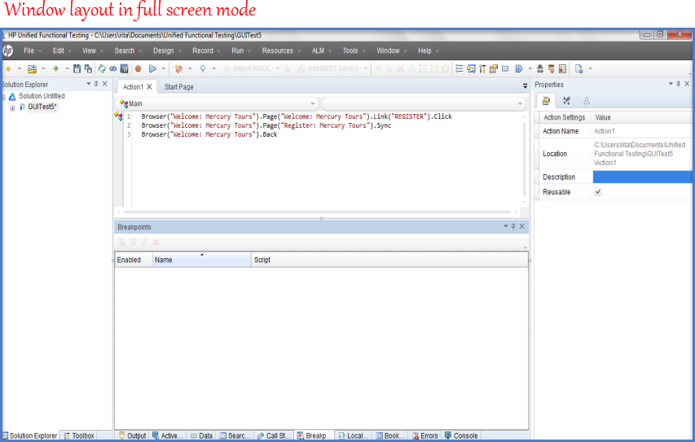](http://www.softwaretestingclass.com/wp-content/uploads/2014/04/UFT-QTP-Windows-Layout.png)

# Output Pane:

In case of GUI testing,Output pane allows user to see information sent during run time by the [Print](http://www.softwaretestingclass.com/overview-of-uft-panes-uftqtp-training-tutorial-5/) Utility statement.

In case of API testing, Output pane allows user to see the Output log for the compilation and test run.

To view this pane, go to View > Output.

[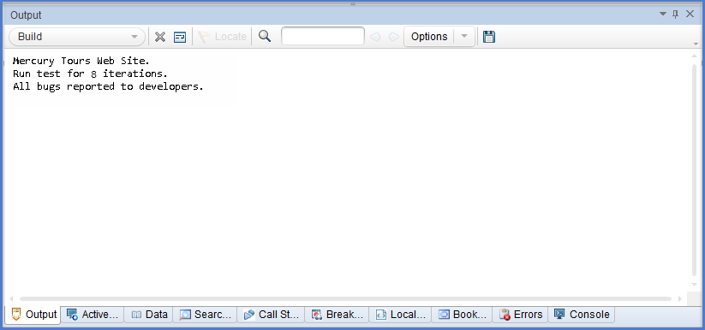](http://www.softwaretestingclass.com/wp-content/uploads/2014/04/UFT-QTP-Output-Pane.png)

# Properties Pane:

The Properties pane displays properties of a test, action, component, function library, or application area and facilitates user to change the properties and parameters too. The information that displays in this pane is totally depends on the active document.

To view this pane, choose View > Properties.

[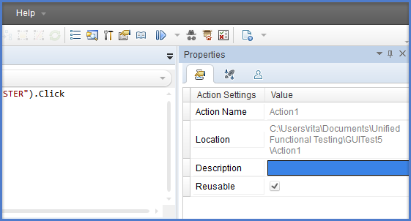](http://www.softwaretestingclass.com/wp-content/uploads/2014/04/UFT-QTP-Property-Pane.png)

# Solution Explorer Pane:

The Solution Explorer Pane shows all resources involve with a test’s component, object, and functions, facilitates user to open all resources in this pane to add, remove, and manage all of the resources involved in particular test. Moreover, the Solution Explorer pane allows users to join multiple types of tests, components, application areas, function libraries, and user code files into a single solution.

User can open the resources and references involved in a test from the Solution Explorer pane by double-clicking on the name of the resource or reference.

To see this pane, go to View > Solution Explorer.

[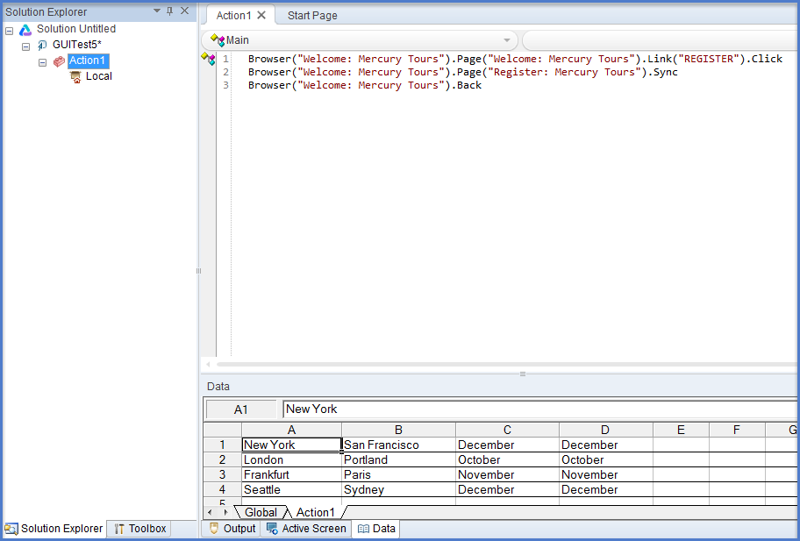](http://www.softwaretestingclass.com/wp-content/uploads/2014/04/UFT-QTP-Solution-Explorer-Pane.png)

# Search Results Pane:

The Search Results pane shows the result, performed by search options from Search [menu](http://www.softwaretestingclass.com/overview-of-uft-panes-uftqtp-training-tutorial-5/), facilitates user to browse the results of the search, locate a specific result, and perform recent searches in order to receive updated results.

To see this Results pane, go to View > Search Results.

[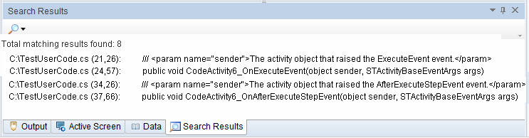](http://www.softwaretestingclass.com/wp-content/uploads/2014/04/UFT-QTP-Search-Result-Pane.png)

# Tasks Pane

Using this pane, user can create, view, and manage the TODO tasks. A TODO task can be anything that should be completed during a test or component, such as giving information applicable for handing over a testing document, or adding a reminder to you to add steps that test a new page in an application. TODO tasks can be saved with the test or component. It also facilitates to see the TODO comments that be in an action, an open function library, or an open user code file.

To show or hide the Tasks pane, select View > Tasks.

[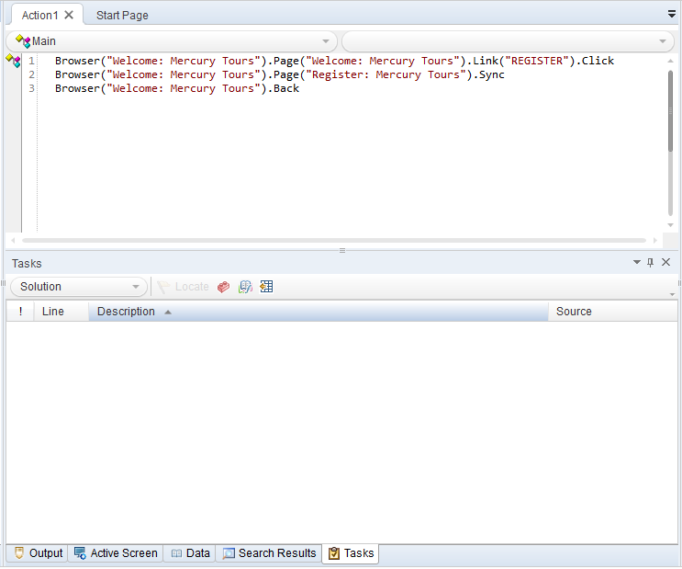](http://www.softwaretestingclass.com/wp-content/uploads/2014/04/UFT-QTP-Task-Pane.png)

# Toolbox Pane:

In case of GUI testing, the Toolbox pane contains all the keywords and functions of a test or component, facilitates user to drag and drop objects or calls to functions into a test or component. While dragging and dropping an object into a test or component, UFT adds a step with the default operation for that object.

In case of API testing, the Toolbox pane contains all the activities and flow control activities useful to generate an API test, facilitates users to drag and drop activities from the Toolbox pane into the canvas to generate a test, or double-click activities to generate a test flow.

In case of BPT, this pane shows all of the components and flows existed to the business process test or flow.

[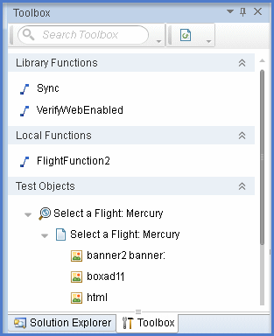](http://www.softwaretestingclass.com/wp-content/uploads/2014/04/UFT-QTP-Toolbox-Pane.png)

HP UFT, an advance version of QTP with combined GUI and API (service) testing platform, provides advance support to the functional and regression automation test. It facilitates user to test the functionality of multiple layers of an [application](http://www.softwaretestingclass.com/type-of-testing-in-unified-functional-testing-uft-12-0-uftqtp-training-tutorial-6/); the front-end GUI layer as well as back-end service layers, both.

Apart from that, its integrated BPT (Business Process Testing) feature provides support to both [technical](http://www.softwaretestingclass.com/type-of-testing-in-unified-functional-testing-uft-12-0-uftqtp-training-tutorial-6/) and non-technical UFT users to generate inclusive automated tests.

The testing services provided by UFT 12.0 are,

* UFT GUI Testing
* UFT API Testing
* UFT Business Process Testing

Overview UFT GUI Testing

UFT GUI (Graphic user interface) testing is one of the automation testing process, given by HP. It is very fast, reliable, repeatable, programmable, comprehensive, and reusable with respect to any other testing process, manual testing process.

There are many drawbacks of manual testing is very time-taken and costly. Time-taken; it is just because of doing everything manually and costly means; heavy investment on human resources. Although, for any project time is very limited, manual tester cannot test the application all functions and object, only limited things can be tested in this case.

Before releasing the software application, it is necessary to test all functions and objects of a particular software application, thoroughly; otherwise various bugs will be released with the release of the application. To come out of bugs issue use UFT GUI automation testing process. Using this, user can create tests that check all aspects of the application or Web site, and these tests can also be run every time when the site or application changes.

[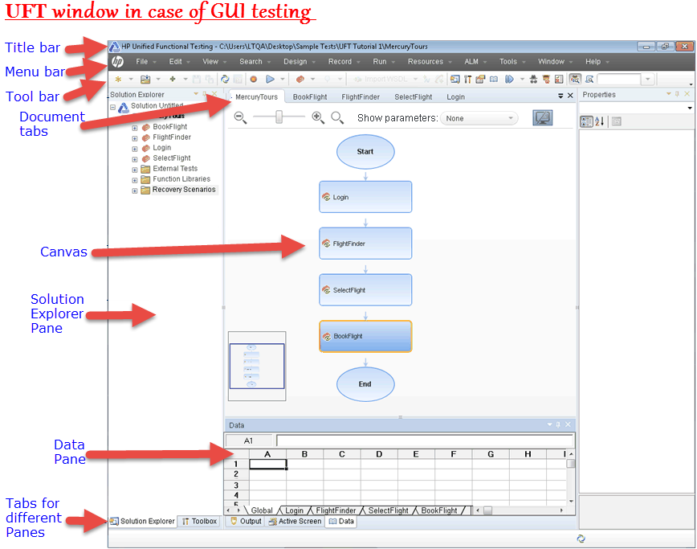](http://www.softwaretestingclass.com/wp-content/uploads/2014/05/UFT-QTP-Overview-UFT-GUI-Testing.png)

# Overview of UFT API Testing

Previously, QTP API testing was given by the Web Service add-in in the form of the standalone Service Test application along with some limited API testing. But now, it’s integrated into a single IDE that offers some great chances to understand API testing.

HP UFT API testing platform having extensible framework helpful in building and executing the functionality of headless systems, systems that do not have a user interface.It is more fast and reliable than the manual testing process.

UFT API testing is helpful to test the headless technologies like; JMS, Databases and Web Services, these technologies are not involved in the API testing toolbox, UFT permits the creation of custom code in C# to enable their testing.

[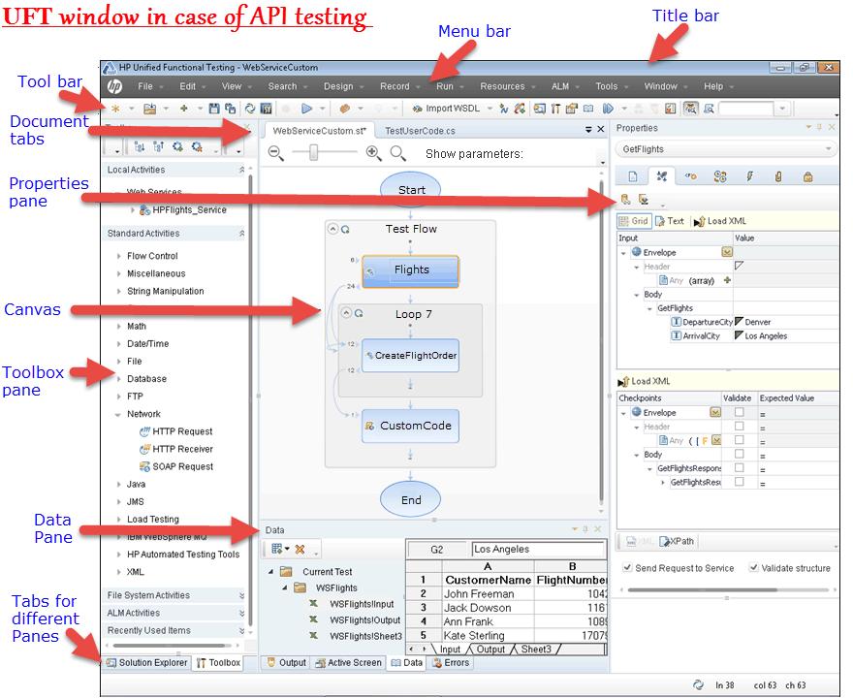](http://www.softwaretestingclass.com/wp-content/uploads/2014/05/UFT-QTP-Overview-UFT-API-Testing.png)

# Overview of UFT Business Process Testing

[HP Business](http://www.softwaretestingclass.com/type-of-testing-in-unified-functional-testing-uft-12-0-uftqtp-training-tutorial-6/) Process Testing provides customized framework for manual testing, automation testing, subject matters testing and component-based testing solution for test design, test creation, test maintenance, test execution, and test data management. The framework is helpful in designing and developing reusable test components and flows based on business process models.

The framework supports component reuse and modularization is helpful in cost management in case of more test creation, maintenance, and execution.

Using BPT framework, user can test simple and complex [application](http://www.softwaretestingclass.com/type-of-testing-in-unified-functional-testing-uft-12-0-uftqtp-training-tutorial-6/) both; an application can be a simple, HTML-based web application or a complex business process including packaged applications and back-end services and databases.

It manages parts of a test contains component documentation, test run results, version control, reporting, and history. Moreover using ALM, user can create documents holding information about the tests, flow, and components in a given project.

In UFT, user can use business process tests and business process flows both to organize their test. UFT Toolbox, Data, and Properties panes can be used to create and edit business process tests and flows. UFT’s BPT project firstly requires ALM project connection with BPT support. BPT in UFT is helpful in creating and editing keyword GUI components, scripted GUI components, and API components.Business process tests and flows can also contain manual testing components.

[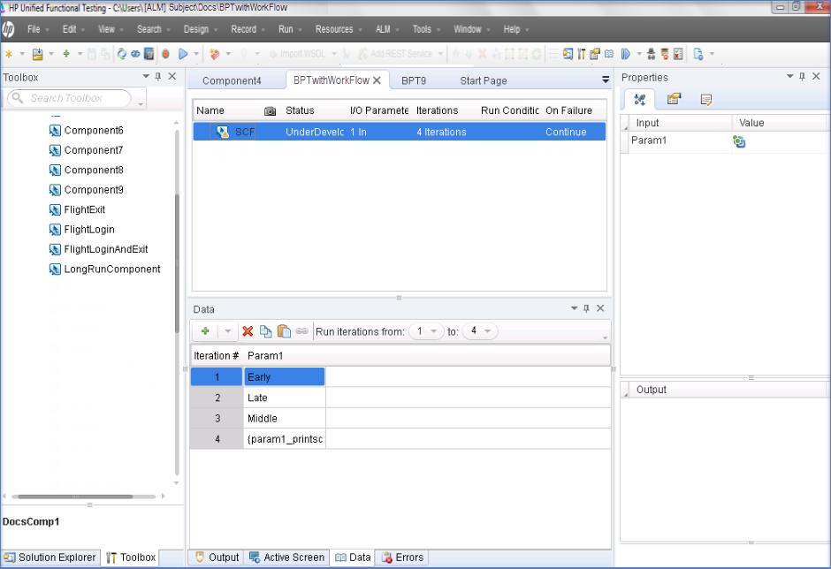](http://www.softwaretestingclass.com/wp-content/uploads/2014/05/Overview-of-UFT-Business-Process-Testing.png)

# Testing Process

The UFT testing process follows the given below steps for test management,

## Step 1) Test application examination

The first step of the test planning process is to examine the application need to be tested,

* **Determine the application’s development environments:**Necessary to know application’s development to load UFT add-ins suitable to that particular environment. Required added Add-ins enables UFT to detect and work with the objects of the application under test. For examples; development environments include Web, Java, and .NET.
* **Decide which business processes and functionality need to be tested:**Think of various activities that customers require [completing](http://www.softwaretestingclass.com/type-of-testing-in-unified-functional-testing-uft-12-0-uftqtp-training-tutorial-6/) specific tasks.
* **How to break test application into small testable units and tasks:**Break the processes and functionality of the test application into smaller tasks that will be helpful in creating UFT actions based on those tasks. Smaller task or action will be easy to read and follow, and maintain.

## Step 2) Creating the testing setup

According to the application testing needs, determine and create the required resources accordingly. For examples; resources contain shared object repositories that comprise test objects that signify objects in the application, and functional libraries that comprise functions that improve UFT functionality. Also, do the required UFT settings to implement any additional tasks like; displaying a results report every time you run a test.

## Step 3) Add required things to build the tests

After creating the test infrastructure, build the test by adding the required things. Create the testing skeletons by creating empty tests and adding action to them, add object repositories with the relevant actions, and add function libraries with the relevant tests, will be helpful to insert steps using keywords. User can also add all application tests to a single solution. A solution allows user to store, manage, and edit any related tests together, without having to [close](http://www.softwaretestingclass.com/type-of-testing-in-unified-functional-testing-uft-12-0-uftqtp-training-tutorial-6/)one test before opening another.’

## Step 4) Improve the test

Test the application functioning properly by inserting checkpoints into the tests. Checkpoints find out specific value of a page, object, or text string. User can add other classy checks to the test by adding programming and conditional or loop statements and other programming logic to the test using VBScript.

## Step 5) Debug, run, and analyze the test

Debug the test by debugging functionality to run smoothly without interruption. After the test runs correctly, run it to check the behavior of the application. While running, UFT opens the application and achieves each step in the test.

## Step 6) Report all defects

Using HP’s ALM test management solution,user can report the detected defects to a database.